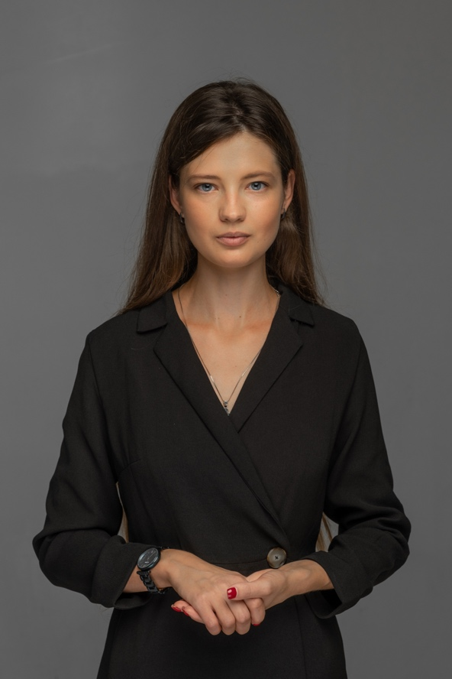

PROFESSIONAL SUMMARY
Highly motivated and team-oriented manager with 7 years’ experience of institutional building, fundraising, working with donors, GR, and project management.
Area of interests includes international relations, international humanitarian law, establishment of new connections, state rebuilding and anticorruption reforms.

SOFT SKILLS
- Responsible  - Сommunicative  - Ambitious  - Creative | - Result-oriented  - Challenge-ready  - Goal-oriented  - Diplomatic
Professional experience
Manager for Institutional Development and Partnership Building
– 02/11/2021 – until now
ULAG, Kyiv, Ukraine
- Legal support (IHL)
- Preparation of grant proposals
- Consulting on strategic development of the organization and search for partnerships
- Project management

Program Grant Manager – 01/2021 – 01/11/2021
JOINT STOCK COMPANY PUBLIC BROADCASTING COMPANY OF UKRAINE (ISC UA: PBC), Kyiv, Ukraine
- Attraction of international technical funding
- Preparation of grant projects, reporting/planning
- Coordination of the signing of grant and cooperation agreements with international partners
- Grant management of the projects

Chairwoman of the Board – 03/2019 – 03/2020
REGIONAL DEVELOPMENT ORGANIZATION E.V., Vienna, Austria
- Management of the organization
- Team building and strategic planning
- Conducting negotiations, partnership development and external communications
- Legal support

Executive Director – 04/2017 – 07/2020
NGO REGIONAL DEVELOPMENT OFFICE, Odesa, Ukraine
- General management of a non-profit organization. Strategic planning, formation of project teams
- Coordination of fundraising activities – UAH 30 million attracted
- Coordination of international technical assistance projects, 12 projects were implemented
- Development of internal and external communications of the organization

Institutional Development Manager – 09/2017-09/2018
APPELLO PARTNERS LEGAL COMPANY LLC, Ukraine
- General management of processes and communication
- Creation of a positive image of the company, preparation of informational materials, communication with media

Alla Smolanka
Contact information:

Mobile phone:
+38(097)787-15-60

E-mail:

a.v.smolanka@gmail.com

Facebook:
Alla Smolanka

LinkedIn:
Alla Smolanka

Head of the Project "Fighting corruption and implementing reforms at the regional level" – 10/2017 -08/2019, Odesa, Ukraine
Planning of project activities, provision of a project implementation plan, public events. There were implemented: 20 trainings for state authorities’ representatives, 2 forums for regional business, 10 trainings for journalists, representatives of civil society and lawyers, 2 international educational trips. Advocacy activity: 13 decisions were made by state authorities.

Project Manager, international project "Mediation and dialogue as a strategy of reconciliation in Ukraine"- 06/2018 – 05/2019
- Team building, project management.
- Ensuring communications with the Federal Ministry of Foreign Affairs of the Federal Republic of Germany, preparation of regular requests for funding in accordance with AA regulations.
- Coordination of the procurement process in accordance with AA rules. Preparation of tender documents and contracts. Communication with banks, counterparties and service providers. Identification of tax refund schemes (as required under the relevant grant agreement).
- Preparation of project reporting and coordination with the donor organization.
- Organization of public events: 35 public events, including international ones were implemented.

Manager of the Department of International Cooperation and Donor Support - 08/2015 – 03/2017
NGO REGIONAL DEVELOPMENT OFFICE
- Organization of fundraising activities, elaboration of a funding attraction strategy.
- Establishment of the cooperation with international organizations, embassies, donors.
- Preparation of project proposals for receiving international technical assistance.
- Monitoring of donor programs, creation of a donor base, communication with donor funds.

Assistant Consultant to the MP of Ukraine, Healthcare Committee – 10/2014-06/2015, Kyiv, Ukraine
- Consideration of incoming correspondence, preparation of answers, development of parliamentary appeals and requests.
- Participation in the development of regulatory documents, preparation of the necessary analytical expertise.
- Organization of internal and external communications of the MP’s office.

Project Founder Political Start-up – 2013-2014. Kyiv, Ukraine

Education
Postgraduate studies: Political Science 2017-2020 (Research topic: Institutionalization of subjects to combat political corruption in modern Ukraine),Taras Shevchenko National University of Kyiv, Ukraine

Master's degree: Political Science 2013 – 2015, Taras Shevchenko National University of Kyiv, Ukraine

Master's degree: Law 2020 - 2022 (specialization - international law)
Yaroslav Mudryi National Law University, Kharkiv, Ukraine

Bachelor's degree: Political Science, 2009-2013,Taras Shevchenko National University of Kyiv, Ukraine

Public and volunteer activities

Member of the Council of Public Control of the National Anti-Corruption Bureau of Ukraine, 06/2016-05/2018, Kyiv, Ukraine.
Volunteer in the team of the head of the Odesa Regional State Administration, 06/2015 – 09/2015
Odesa Regional State Administration, Odesa, Ukraine

Fundraising trainer (2016-2025) for non-profit and for-profit organizations. Certified trainer for institutional development and partnership building, attraction of external funding on the cd-platform.

