Curriculum vitae
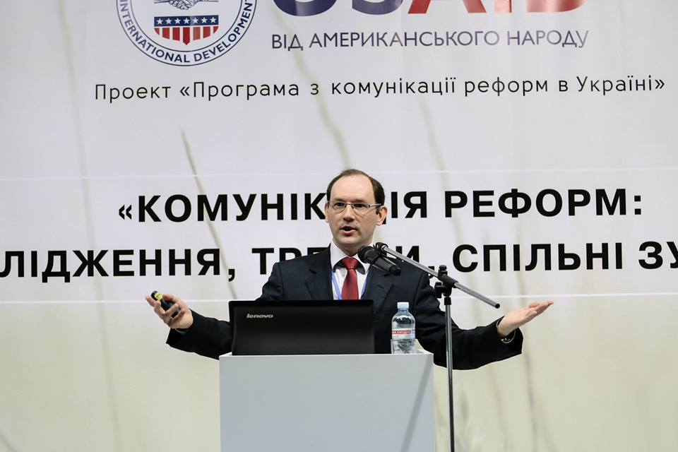

1. Family name: Kulakov
2. First name: Andriy
3. Date of birth: March 31, 1979

4. Key qualifications:
Mr. Kulakov has solid managerial experience with mass media and non-government organizations. Before joining Internews-Ukraine, Mr.Kulakov worked for the TV Channel 5th and for a local donor organization. As a Program director of Internews Ukraine he is responsible for administration of all Internews-Ukraine’s projects, including those funded by the EU Delegation, USAID, World Bank, EU member states’ embassies, etc. The scope of his responsibilities includes fundraising activities, contacts with donors, overall supervision of the projects, coordination of the work of project managers, strategy building and preparation of all reporting documents. Mr. Kulakov represented Internews-Ukraine at international NGO platforms including Easter Partnership Civil Society Forum. Mr. Kulakov was a Board member in Ukrainian Think Tanks Laison Office in Brussels. He is also a consultant in communication and PR, in particular for awareness campaigns and strategies. He is a trainer in communication (his on-line course in English is available here), advocacy and media literacy. He has contributed to Ukrainska Pravda, Den’ Newspaper, Telekritika etc. Mr.Kulakov is an editor and co-author of several manuals and books in media- and journalism-related issues published by Internews-Ukraine. The last publications he has contributed to are Reforms Guide, Words and Wars: Ukraine Facing Kremlin Propaganda, Taming the Hydra: How to Resist Kremlin’s Information Aggression?, Ukraine in Histories and Stories: Essays by Ukrainian intellectuals
Mr.Kulakov is also an expert of OSCE Project Co-ordinator in Ukraine, Council of Europe in Ukraine and a non-staff Adviser for the Head of Center for Countering Disinformation (under National Security and Defense Council of Ukraine)
Mr. Kulakov is also one of the co-founder of Ukrainian Aspen Club, a local NGO uniting the alumni of Aspen Seminars in Ukraine. Mr. Kulakov is also cooperating with Aspen Institute Kyiv as a moderator of Aspen Leadership Seminars (in Ukraine and globally) and Manager of Institute’s Society of Fellows.
Education:
Institution  (Date from-Date to) | Degree(s) or Diploma(s) obtained:
Aspen Institute, Aspen, CO, USA  (September 2006)  Aspen Institute/Viktor Pinchuk Foundation, Ukraine, Yalta (January 2008) | Certificate of the Aspen Leadership Seminar
Newsplex Convergence Training  Teaching and Research in Convergent Journalism  IFRA, Columbia, SC, USA | Certificate of Newsplex Convergence Training
Philosophy Institute of National Academy of Science  July 2002 – | PhD studies
The National University of "Kyiv-Mohyla Academy", master program in history of philosophy  September 2000-June 2002 | Master degree in philosophy (diploma with honors)
The National University of "Kyiv-Mohyla Academy", Department of Humanities, 1996-2000 | Diploma of Bachelor of Arts in philosophy with honors
University of M.Curi-Sklodowska (Lublin, Poland)  May, November 1998 | Fieldwork at Philosophy & Sociology Department
8. Participation in trainings
25 – 31 October 2009 | Training Session by Council of Europe “Voluntary Service and Intercultural Dialogue” (Budapest, Hungary).
November 2008 | Financial management for media-companies  Internews-Ukraine, (Kyiv, Ukraine)
25 June 2008 | Media workshop by Yegor Sobolev “How to deliver a brilliant interview”
18 May 2006 | Master-class by Stephen Covey “Strategic leadership”  (Kyiv, Ukraine)

Language skills: Indicate competence on a scale of 1 to 5 (1 – basic; 5 – excellent)
Language | Reading | Speaking | Writing
Ukrainian | 5 | 5 | 5
Russian | 5 | 5 | 5
English | 5 | 5 | 5
Polish | 5 | 5 | 3

Training and consultancy experience
Date from - Date to | Location | Company | Description of responsibilities
2013 – 2014 | Kyiv, Ukraine | Ukrainian Chamber for Commerce and Industry | Communicational audit; developing the communication strategy; PR training for press-officers of local chambers
2014 | Kyiv, Ukraine | Green dossier | PR and communication training for local NGOs and businesses in organic agriculture
2015 | Kyiv, Ukraine | DVV International in Ukraine | PR training for local NGOs and media outlets from 5 regions of Ukraine
2016 | Georgia, Azerbaijan,  Armenia | British Council | Expert in Communication and Advocacy (training in communication and advocacy, briefings on media development, on-line course in communication)
2017 | Ukraine | USAID,  Cabinet of Ministers of Ukraine | Local Expert in Communication in the project of Communication of Reforms in Ukraine (communication of Public Health and Energy Reform)
2017 | Ukraine | EU Delegation in Ukraine,  Cabinet of Ministers of Ukraine | Coordinator in Communication of Public Administration Reform in Ukraine
2018 | Ukraine | Ukrainian Catholic University\ Practicum Program | Trainer and consultant in communication within the Practicum Training Program
2018 | Ukraine | EBRD | Trainer and consultant in communication for small business in Ukraine
2019 | Ukraine | Creative Europe Program (funded by the EU) | Trainer and consultant in project management
2021 - present | Ukraine | RADA: Next Generation  USAID Activity | Communication Director
Jan – Nov 2023 | Ukraine | Support to Decentralisation Reform in Ukraine – U-LEAD with Europe Phase II  GIZ (Germany)  Internews Ukraine | Trainer and consultant on communication for local communities

General professional experience
Date from - Date to | Location | Company | Position | Description of responsibilities
November 2021 - present | Kyiv, Ukraine – | RADA: Next Generation  USAID Activity | Communication Director | Strategic communication of the Activity, management of the comm team, management of the Enhancing Comm Capacities of the Verkhovna Rada of Ukraine component
February 2019 - 2021 | Kyiv, Ukraine –  Brussels, Belgium | Ukrainian Think Tanks Laison Office in Brussels | Board Member | Strategy building; fundraising
2018 - present | Kyiv, Ukraine | Aspen Institute Kyiv | Manager of Society of Fellows; moderator of seminars | Development of Institute’s alumni;  Organization of the Institute seminars;
August 2006-present | Kyiv, Ukraine | NGO “Internews-Ukraine” | Program Director | Responsible for developing business and strategic plans and for monitoring Internews-Ukraine project implementation, fund-raising activities, overall administration of all Internews-Ukraine’s projects, including raising awareness campaigns.
June 2005-August 2006 | Kyiv, Ukraine | NGO “Internews-Ukraine” | Assistant of the Board Chair, then Information and Grants Officer, Project Coordinator | Developing concept of new projects and initiatives, writing proposals, supervising and coordinating a series of media-related projects, monitoring and reporting on the projects results
February 2005-June 2005 | Kyiv, Ukraine | “5th Channel” TV Company | Input editor | News selection; coordination of reporters; news writing; video editing.
February 2003-July 2004 | Kyiv, Ukraine | NGO “Center for Land Reform Policy”, | Information Manager | Media monitoring; web site updating; development of media documents
April 2002-2005 | Kyiv, Ukraine | NGO Youth Humanities Center | Chief Manager | Laboratory of Scholar Translation Project
January 2000-September 2001 | Kyiv, Ukraine | NGO Youth Humanities Center | PR-Manager | Coordinating of conferences, discussions, summer schools, presentations, negotiations, international cooperation
2001 | Kyiv, Ukraine | Kievskie Vedomosti Radio Station  Era TV and Radio Company | Scriptwriter | Scriptwriting for:  Radio program on cultural news;  TV program “Hi-Tech”
September-November 1999 | Kyiv, Ukraine | Institute for Political & Ethno-political Researches of Ukrainian National Academy of Sciences | Media Monitoring Center, mass-media operator | Media Monitoring
April-December 1997 | Ukraine | Weekly Newspaper in Agricultural Business "Selyanska Spilka | Journalist, Analysis Department Chief Manager | Journalist (professional fields: political parties, banks, Southern Ukraine);  Analysis Department Chief Manager (press monitoring, weekly press review, data bases)

Other skills:
Managerial experience (from 2006) in particular, in project management and management of an NGO, excellent communication skills; understanding of the financial management in third sector; vast experience in public events organization and awareness campaigns; experience in intersectoral partnership building; computer skills; good presentations skills; translation experience (from Polish and English into Ukrainian – publications made by Osnovy, Smoloskyp).

Contacts:
Andriy Kulakov
Cell phone: +38 067 243 63 56
E-mail: andriy.kulakov@gmail.com

